**Task 3 - Image manipulation**

Quen 1 - .shape and .size

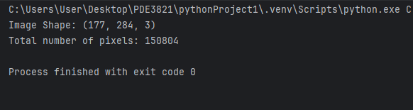

Quen 2 - RGB - Gray

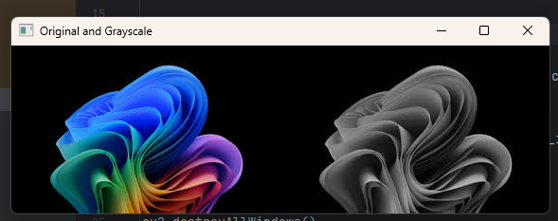

Quen 3 - Binary image using threshold method (threshold value at 255)

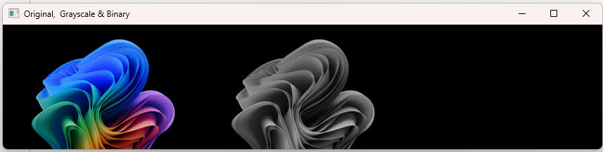

Quen 3b - Binary image using threshold method (threshold value at 128)

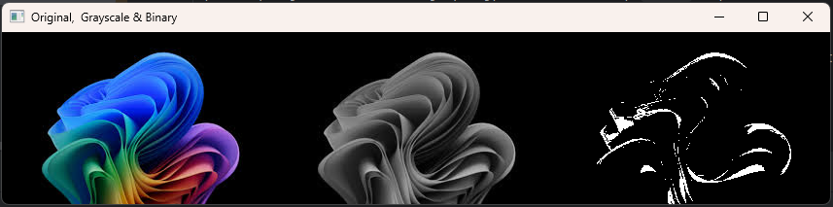

Quen 3c - Binary image using threshold method (threshold value at 64)

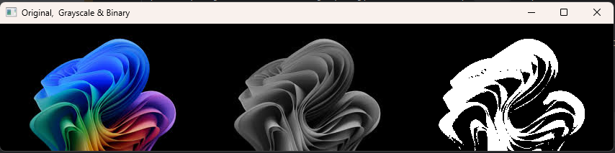

Quen 3d - Binary image using threshold method (threshold value at 64)

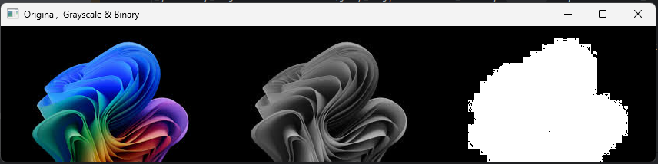

Quen 4 - Using average blur and gaussian blur

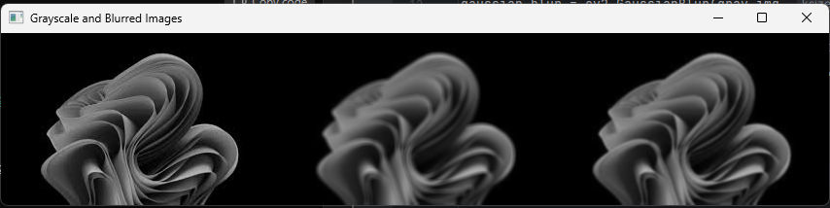

Quen 5 - Edge detection

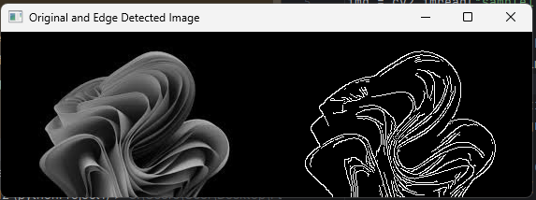

Quen 6 - Resize image

